Work Instructions for making new earth pit and Maintenance of Earth pit
Scope: All over the plant

Ref: IS 3043 rev code of practice for earthing
- Aspect: Nil
- Impact: Nil
- Hazards: Electrocution while digging due to presence of live underground cable ; Electric shock while using electric breaker, use of improper tools, fall of person in pit , electric shock during earthpit resistance measurement using earth tester, earthpit repair.
- Ensure work permit is taken before starting the activity of earth pit digging .
- Ensuree area under digging is free from underground cable, pipe lines etc.
- Ensure Electrical portable tools are cerfied before use
- Ensure hard barricading is done for the area wheree digging is done, to avoid fall of person.
- Check and certify all the tools used for the activty are safe for use .
- Earth pit installation has to be done strictly as per the IS 3043 rev code of practice for earthing.
Responsibility: Engineer Incharge

- Depending on the requirements, earth pit to be made according to approved drawing Fig No1 or Fig No2
For transformer & generator neutral copper plate type earthing to be followed as per Fig 2 & for body earthing GI plate type earthing to be done as per Fig 1.

- Dimension of earth electrode,earth strip ,pipe & pit shall be witnessed and certified by Engineer Incharge before excecution of earth pit filling activity.

- Filling of earth pit with salt and charcoal and placement of the earthplate and electrode to be done as per the approved drawing and to be witnessed by Engineer Incharge.

- Funnel with strainer to be placed on the earthpit for watering pipe as shown in fig no 1& 2.

- Chamber of size 300mm x 300mm with CI cover to be provided. Chamber to be of size as shown in fig.
Responsibility: Engineer Incharge.

- Every earth pit installation has to be provided with identification board of size 250mm x 250mm as per fig no.3
Responsibility: Engineer Incharge.

- All earth continuity conductor shall be of copper neutral earthing , and GI for body earthing
Responsibility: Engineer Incharge.

- Earth pit overall maintenance as per the APM check list FRMT/ELECT/03 has to be carried out once in a year by a competent authority having a valid license issued by state government.
Responsibility: Engineer Incharge.

- It is recommended that the value of any individual earth system resistance shall be less than 05 ohms If it is a grid earthing , value of earth resistance shall not be more than 01 ohm. If Earth resistance value is higher then specified, corrective actions like watering /reconditioning of earth pit has be taken up.
Responsibility: Engineer Incharge.

- Check and ensure that earth megger used for measuring earth resistance is having a valid calibration test
Certificate
Responsibility: Engineer Incharge.

- Certification of earth pit made shall be done only after completion of extra job as per the drawing.

GI PLATE EARTHING 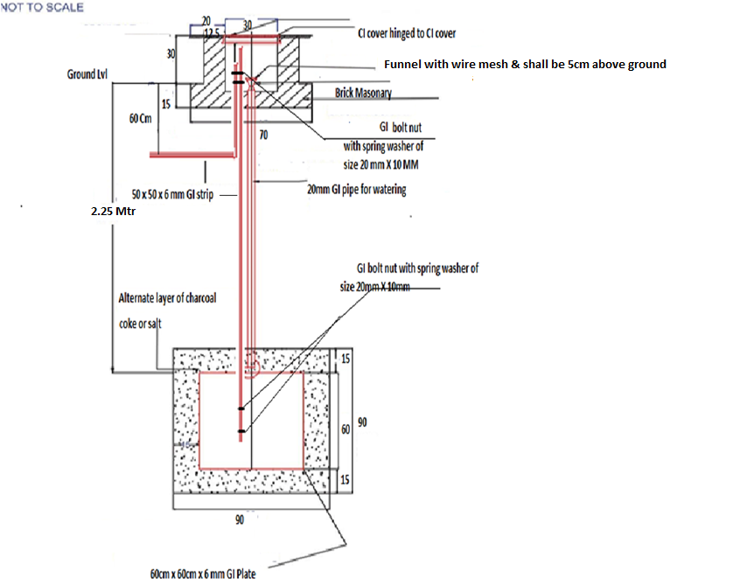
Fig - 01

COPPER PLATE EARTHING

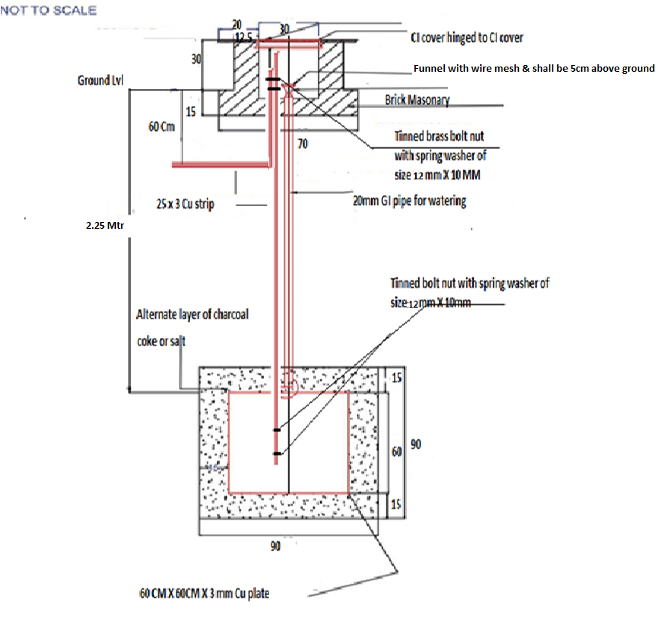
Fig No.2

EARTH PIT BOARD
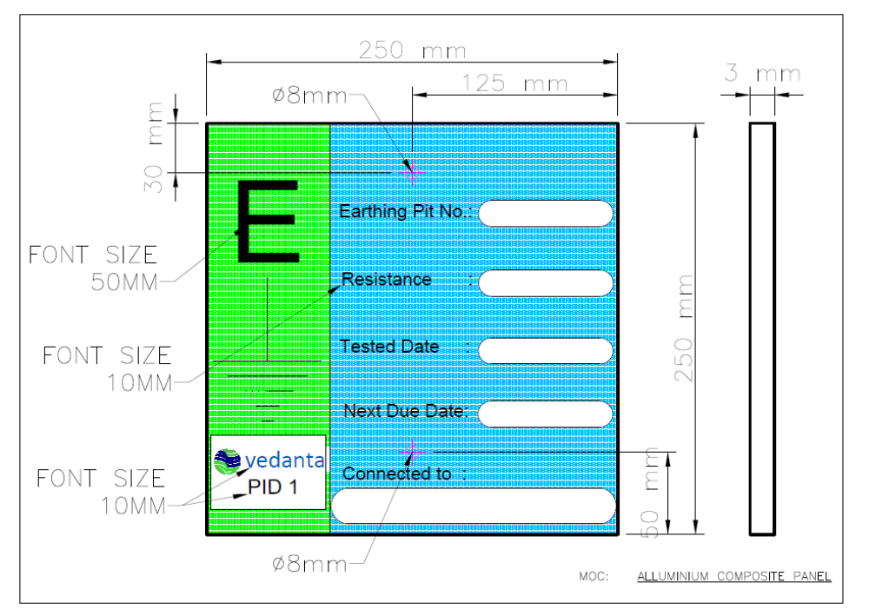
Fig No.3

Method of Earthpit testing by earth tester- (Three point method):

- Earth tester terminal C1 & P1 are to be shorted to each other and connected to the earth electrode under test.
- Drive a probe into the earth 50 meters from the center of the electrode and connect to terminal C2. This probe should be driven to a depth of 6 – 12 inches.
- Drive another probe into the earth midway ( 25 meters) between the electrodes and probe C2 and connect to terminal P2. This probe should be driven to a depth 6 – 12 inches.
- These two probes are to be kept in the same line
- Record the resistance measurement.
- Note: At the time of test , the test electrode shall be seperated from the system.

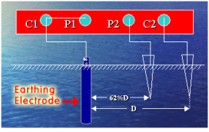
Hazards involved during earthit testing
- Earthtesters generate direct current , hence do not operate the earthtester when in contact with the terminals C1 and C2( Current terminals).

Amendement Record
Date | Manual Section Ref. & Para | Brief details of Revision | New Rev.

Prepared By:  Senior Elect. Engineer | Reviewed & Issued By:  Management Representative | Approved By:  Head – Electrical & Instrumentation PID I
Signature | Signature: | Signature:
Review Date: 04.03.2023 | Review Date: 04.03.2023 | Review Date: 04.03.2023

